Joshua No2 — Brokerage Listing Brochure
Vessel Identification and Overview
Joshua No2 offers a superb opportunity to acquire a vessel that embraces the rich heritage of the inland waterways. This traditional stern narrowboat, carrying the registration index number 52149, combines classic aesthetics with practical liveaboard or cruising features. The following specification highlights the vessel's key attributes. A comprehensive in-person inspection are advised to verify complete technical specifications and mechanical integrity prior to purchase. The vessel has had a hull survey carried out in April 2026.
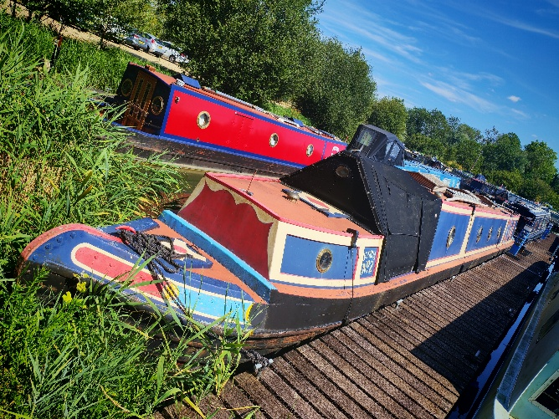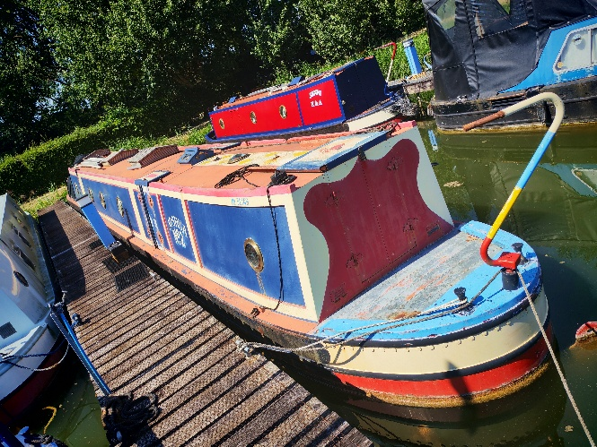

Exterior Profile and Hull Configuration
The vessel boasts a classic traditional stern and a standard narrowboat bow profile, thoughtfully fitted with a black canvas cratch cover mounted upon a wooden A-frame to provide protected external space. The exterior cabin sides are beautifully finished in a dark blue livery, elegantly complemented by cream and yellow coach lines and a deep red inset on the aft panels. The roof is painted in a traditional red oxide colour, accented by a striking central decorative diamond pattern executed in yellow, cream, and blue. Traditional wooden handrails, a low-profile mushroom vent, and a classic pigeon box skylight over the engine room complete the authentic roof profile. Standard fore and aft mooring bollards are present, alongside conventional centre roof rings for secure handling.
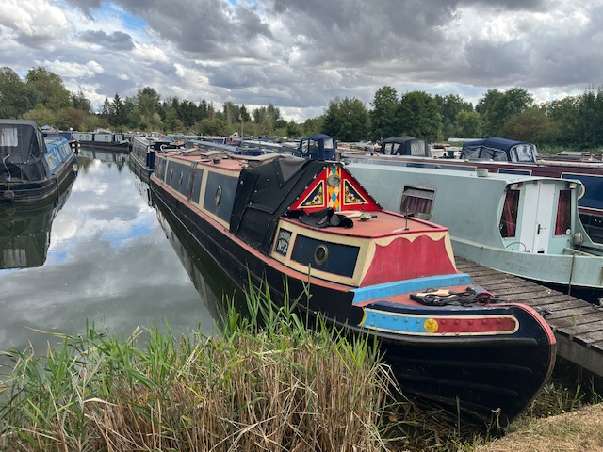

Engine Room and Mechanical Installations
A dedicated mid-ships engine room separates the aft boatman’s cabin from the forward accommodation. Powering this vessel is a meticulously presented Lister JP2, a vintage two-cylinder marine diesel celebrated for its uncompromising reliability and immense low-end torque. Delivering 21 bhp at 1200 RPM, it effortlessly swings a large propeller for steady, highly efficient displacement. The engine room perfectly marries maritime heritage with modern utility: traditional Lister green livery, polished brass detailing, and a striking red flywheel sit alongside a robust PRM hydraulic gearbox and a twin-belt marine alternator. This is an exceptional, ready-to-cruise power plant offering the best of historic engineering and contemporary, dependable performance.
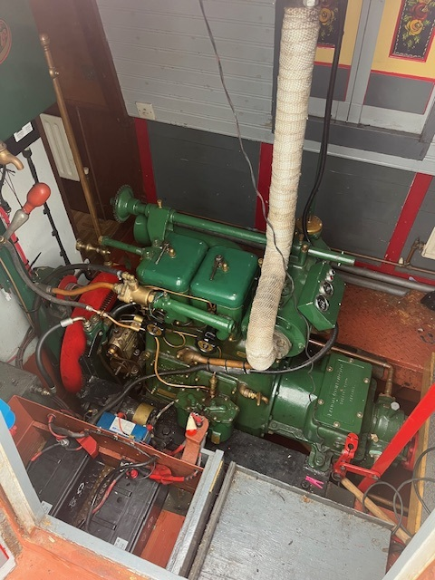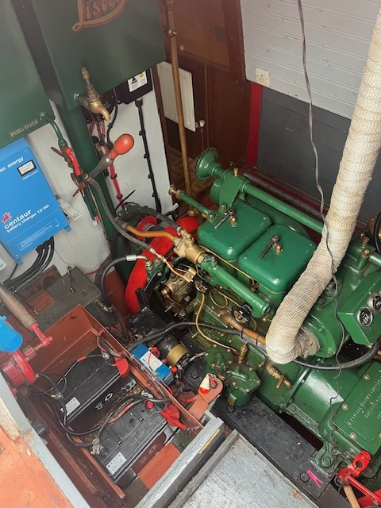

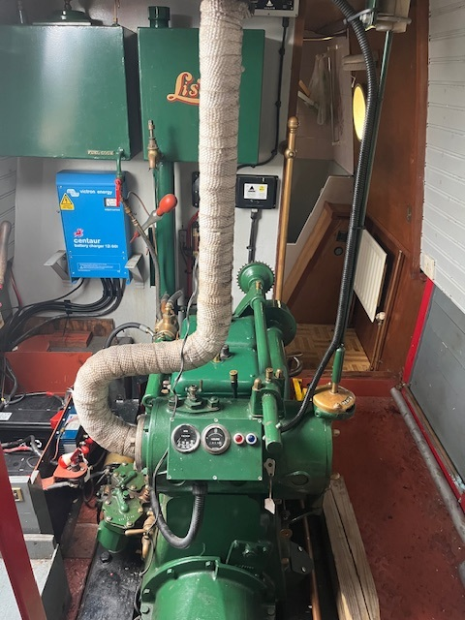

Aft Accommodation — Traditional Boatman’s Cabin
The aft section is meticulously fitted as a traditional boatman's cabin, providing a highly desirable feature for enthusiasts of historical canal craft, as viewed from the rear access hatch. The woodwork showcases extensive scumble glazing framed in deep red, faithfully recreating historical working boat traditions. Authentic traditional canal art, specifically 'Roses and Castles', beautifully adorns the door panels, ticket drawers, and bulkhead facings. Additional painted detailing surrounds the brass portholes and panel work. Heating in this cabin are met by a charming cast-iron solid fuel boat range, complete with a brass rail and a dedicated flue. Brass portholes and traditional oil-lamp style electric wall sconces create a warm, inviting atmosphere. The cabin cleverly incorporates standard drop-down hatches for the table and cross-bed configurations typical of historical vessels. For precise operational control, a brass speed wheel and gear selector rod are strategically positioned at the aft doorway, allowing traditional steering from the rear step.
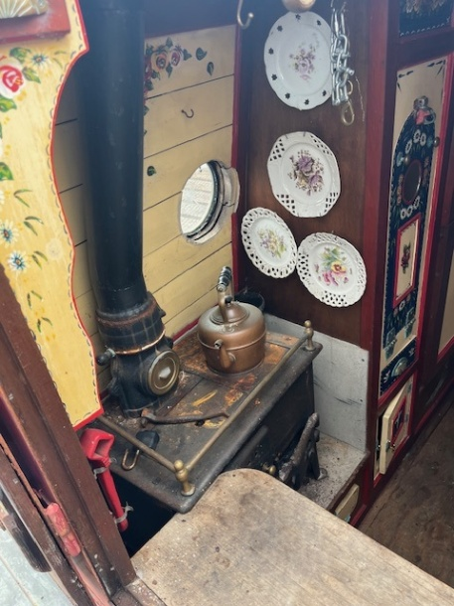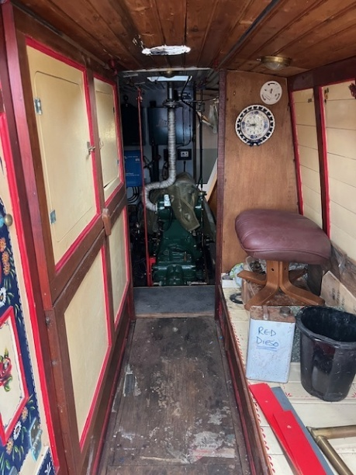

Galley Facilities
Positioned mid-ships, the walk-through galley provides a practical and attractive transition into the forward saloon. Generous base cabinetry is fitted on both the port and starboard sides, featuring wooden cupboard doors uniquely decorated with hand-painted floral motifs. The upper cabin sides are finished in bright, pale green painted tongue-and-groove panelling. The work surfaces are finished in a practical pale laminate. The starboard side incorporates an inset stainless-steel sink and drainer fitted with a modern mixer tap, whereas the port side houses a convenient four-burner gas hob. Designated surface space is also available to accommodate a freestanding microwave oven, blending traditional aesthetics with modern convenience. Glazed wooden doors provide an elegant separation between the galley space and the aft corridor leading to the washroom and engine room.

Saloon Configuration
The inviting open-plan saloon is positioned immediately forward of the galley, featuring extensive varnished tongue-and-groove timber cladding across the ceiling and upper cabin sides to create a warm and spacious environment. Natural light is provided by classic brass portholes dressed with fabric curtains. A solid fuel stove provides a superb focal point on the port side, mounted upon a tiled hearth with a matching tiled surround displaying intricate geometric and floral patterns. The primary seating configuration consists of a substantial fitted L-shaped dinette or sofa unit upholstered in a heavy floral fabric, whilst still leaving sufficient floor space for freestanding furniture. The forward bulkhead features a bespoke built-in shelving unit with decorative patterned tile backing and traditional painted floral borders, alongside an integrated stereo system. Minor cosmetic wear at the joinery seams offers a simple opportunity for the new owner to add their finishing touch and add value.
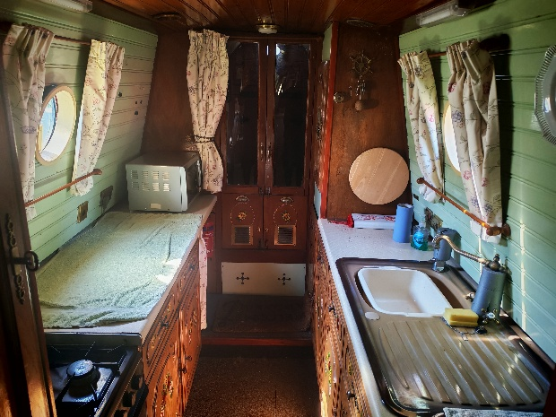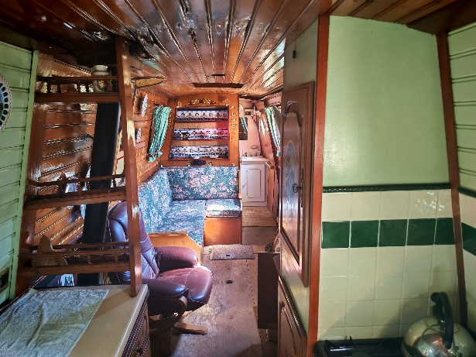

Washroom and Sanitary Facilities
The practical washroom features a compact vanity unit with an inset washbasin, traditional separate hot and cold taps, and a tiled splashback, with a mirrored cabinet mounted directly above. Bathing facilities consist of a space-efficient moulded grey deep shower tray or compact hip bath, fitted with a flexible mixer shower attachment and surrounded by pleasant pink floral pattern tiling. The space is currently configured to utilise a portable cassette sanitation system, with two cassettes stored efficiently within the shower tray area. The wooden panelling surrounding the exterior of the bath enclosure is currently prepared for finishing, presenting a straightforward completion project for the purchaser to tailor to their standards.
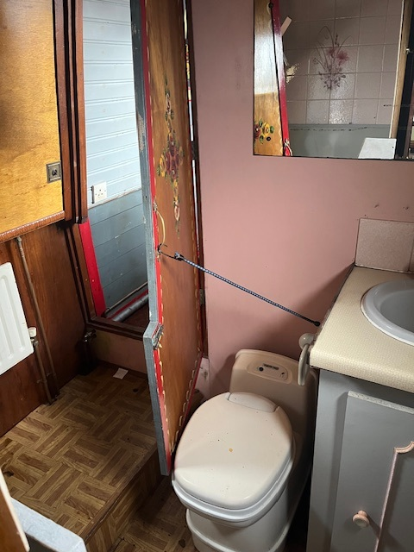
Forward Cabin
Positioned at the bow of the vessel, the forward cabin serves as a comfortable and private primary bedroom. The space contains a raised, fixed bed frame featuring highly practical built-in wooden storage drawers underneath, detailed with traditional painted floral motifs matching the vessel's character. Full-height bulkhead cupboards provide extensive storage capacity, finished in a striking solid terracotta colour and heavily accented with ornate, traditional black ironmongery. The space is well-illuminated by overhead dome lighting and natural light from the adjacent brass portholes, completing this highly attractive traditional narrowboat. The bow cabin provides a comfortable private bedroom.
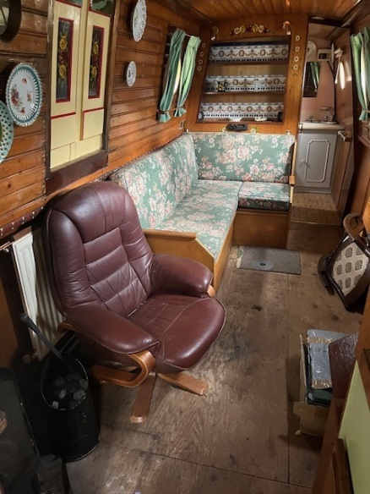

Summary
Joshua No2 is a beautifully presented traditional narrowboat offering authentic heritage features alongside practical liveaboard comforts. Its traditional engine room, boatman’s cabin, and well-appointed saloon and galley make it an excellent candidate for enthusiasts seeking a classic vessel with character and charm. Joshua No2 would benefit from some loving care and refurbishment.

