DAWN DANCER
60FT NARROWBOAT — SALES PARTICULARS

Vessel Identification & Exterior
Vessel Name | Dawn Dancer
Registration No. | 517264 (Index No. 108)
Length | 60ft (18.28m)
Region | Kennet & Avon
Coachwork & Livery | Deep navy blue primary panels with cream upper borders, deep red lower hull bands, and traditional white signwriting. Porthole windows fitted with polished brass bezels.  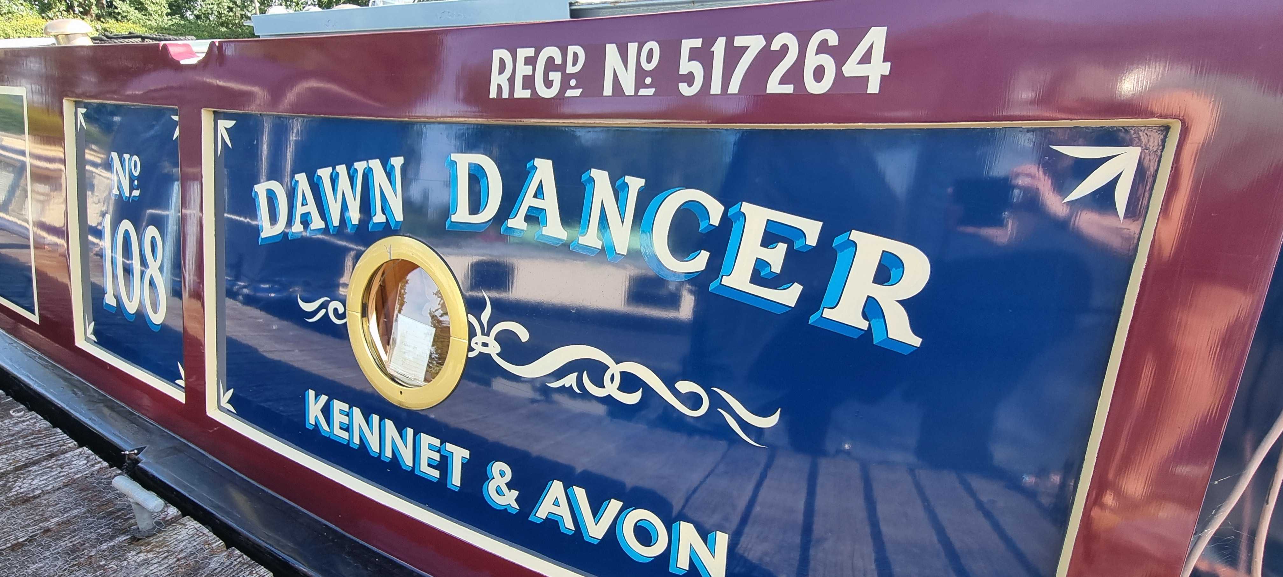
Stern & Deck | 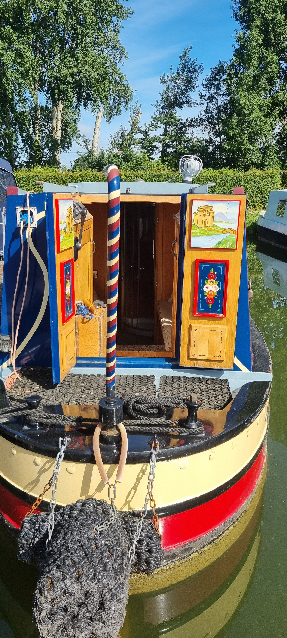  Traditional aft deck layout features a highly decorated barber-pole tiller pin. Aft doors display exquisite hand-painted traditional 'Roses and Castles' detailing.

Engineering & Electrical Architecture
Power Management | Victron Energy Digital Multi Control (Inverter/Charger) paired with a Victron Energy BMV-700 Battery Monitor, ensuring precise oversight of the vessel's power state.  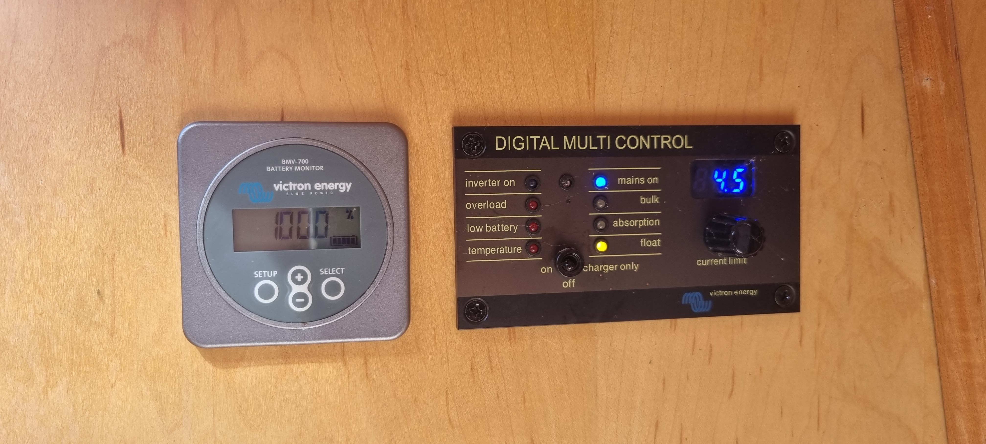
Electrical Distribution | L&T Marine bespoke distribution panel offering isolated 12V DC (Pumps, Navigation, Aux) and 230V AC (Sockets, Mains) circuits. Professional marine-grade switching and breakers.
Domestic Battery Bank | Heavy-duty red domestic storage cells, safely secured with webbing straps within a purpose-built structural timber enclosure. Professional high-gauge cabling and crimped terminal isolation.
Heating Systems | Webasto diesel-fired central heating system (control interface adjacent to the main electrical board), supplemented by a solid fuel multi-stove located in the forward saloon. Panel radiators installed throughout.

Interior Layout & Accommodation
Saloon | Open-plan forward saloon trimmed in light ash/oak veneered panelling. Furnished with twin cream leather swivel recliner chairs and footstools. Port-side solid fuel stove, corner entertainment cabinetry, and a space-saving drop-leaf dining table stowed beneath the starboard gunwale.  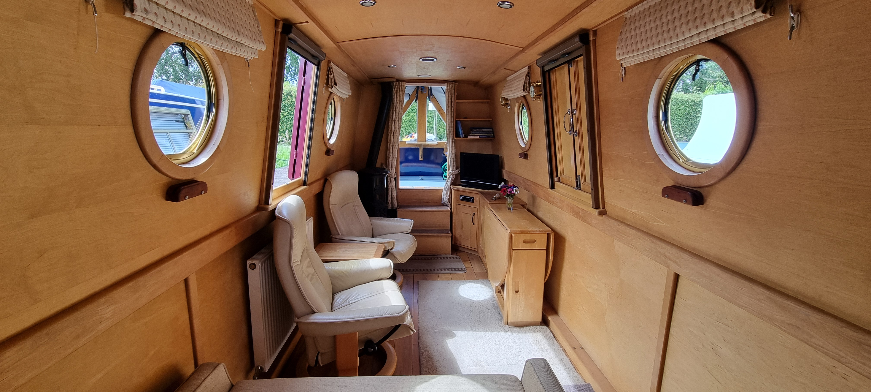
Galley | Generous U-shaped aft galley featuring dark stone-effect laminate work surfaces and complementary tiled splashbacks. Domestic-sized four-burner gas hob with separate oven and grill. Under-counter 12V/230V refrigerator. Integrated Panasonic microwave oven positioned on custom shelving. Stainless steel circular sink with monobloc mixer tap and dedicated drinking water filter tap.  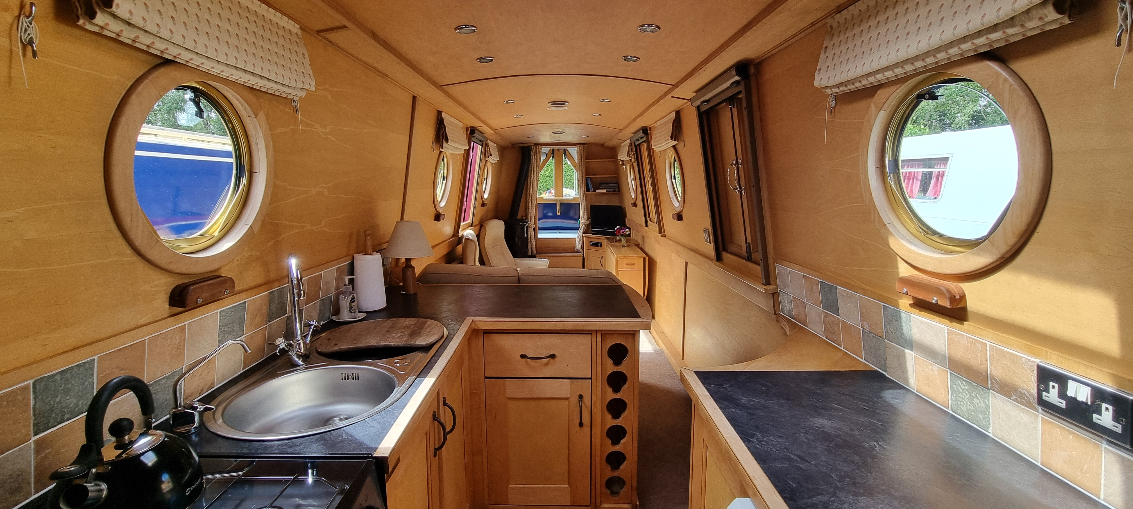

Cruising Inventory & Ancillaries
The vessel is fully equipped for immediate active cruising. A dedicated utility locker houses essential deck hardware in an organised manner, including:
- Heavy-duty mooring chains and nappy pins for varied piling and towpath moorings.
- Multiple lock windlasses and a traditional wooden mooring mallet.
- Deck umbrella and general boatman's operational equipment.

Strictly factual brokerage details compiled for reference. Measurements and specifications are provided for guidance and should be verified independently.

