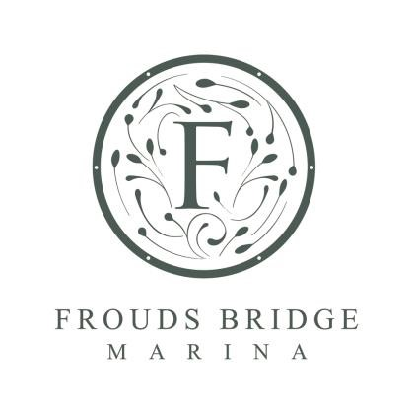
Quidlibet

45ft Trad Stern
Built by Nick Thorpe
Price - £53,000 ono

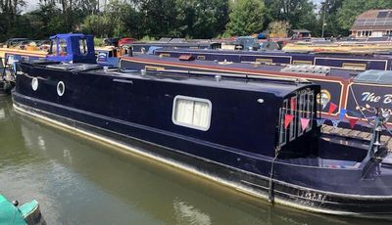
This is a lovely narrowboat that has been lovingly outfitted and maintained by the current owner, with no expense spared. Unusually for this size of boat, it is fitted with a bath for that extra luxury.

Quidlibet is a 45’ semi-trad stern built by Nick Thorpe in 2014 and fitted out by the current owner. The boat has been finished well and is in a great turnkey state. Externally, Quidlibet has been finished in a single coat of dark blue gloss paint, which, as you can see from the pictures, has been well maintained. Internally, it has been finished with white panelling and a T&G style roof, giving the internal cabin space a light and bright feel.

Starting at the Stern deck, you step down into the back cabin, which has been built with both storage and comfort in mind. The back space is both a practical room to fettle with the engine, batteries, or alike, as well as a comfortable, private, and spacious king-size fold-down bed. When the bed is down, there is loads of room underneath to store things such as bikes or boxes.

Moving forward into the bathroom, you will notice straight away that there is a full-size bath with a shower overhead. Usually, baths are impractical; however, the owner has thought of this with a 900-litre water tank and 90l calorifier, making a bath on a boat very possible indeed. There is still ample room for the sink and toilet, which, given the size of the boat, is proportionally huge.

Next, you will come to the galley kitchen, which has plenty of storage, creating ample countertop space. The galley gives you everything you need for cruising, with a practical induction hob and microwave, as well as a full-sized under-counter fridge and washing machine. Slightly further forward, we come to another set of shorter storage units with the top doubling up to become either bench seating on two single beds. There really is ample storage onboard.

Finally, we move to the Saloon, which gives a nice little space to sit down for an evening meal around the round table whilst looking out the beautiful front doors and well deck.

New professionally made curtains will be fitted for early spring.

Boat Specification
Year of Construction | 2014
Hull Plating Specification | 10-6-4
Keel | Flat
Draft | 2 ft
No. Berths | 2 + 2
History of Vessel / Maintenance
Boat Safety Certificate Expiry | March 2027
Latest Hull Blacking | 2 Pack 2023

Engine Specification

Engine Make | Barras Shire 45
Engine Hours | 2911 Approx
Bow Thruster | No
Diesel Tank Capacity | 175 litres
Water & Heating Systems
Source of Hot Water | 90lt Calorifier
Central Heating | Eberspacer diesel heater + 4 radiators
Hot Water | Eberspacer diesel heater
Water Tank Capacity | 900 Lt
Water Tank Material | Stainless Steel

Electric Specification

12-Volt System/Lighting | Standard
12-Volt System/Power | Standard
240 Volt | Shore power / Inverter
Inverter | 3kw Victron
Solar Panel | Solar Panels + MPPT charge controller
Batteries | 4 Domestic / 1 Starter battery
Bathroom Specification
Type of Toilet | Cassette Toilet
Shower/Bath | Shower and Bath
Handbasin | Bowl with Vanity Unit
Kitchen Specification
Cooker | Microwave
Hob | Induction Hob (New 2025)
Fridge | 240-volt fridge
Gas | Twin Calor 13kg
Washing Machine | Hoover
Additional | New Fresh and Bilge Pumps 2025

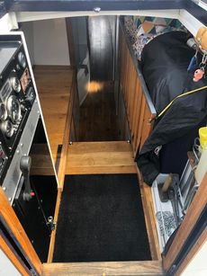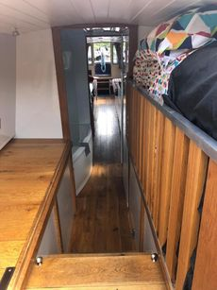

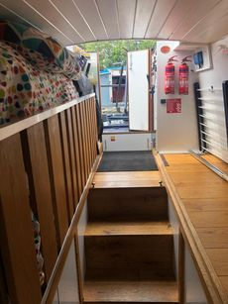

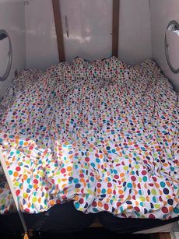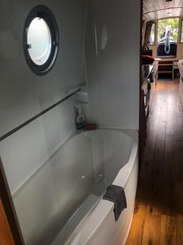

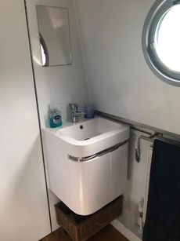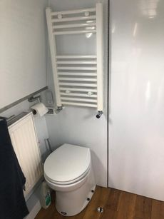

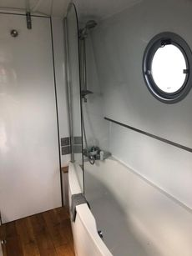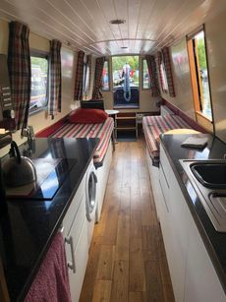

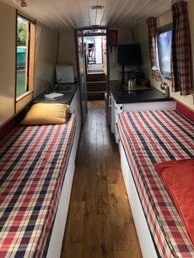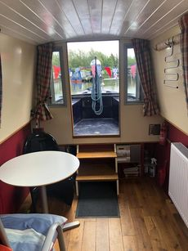

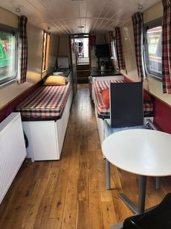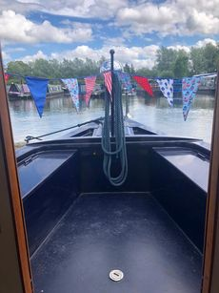

This sale is not related to the
Owner’s business, trade or profession. Whilst every care has been taken in their preparation, the correctness of these particulars is not guaranteed. The particulars are intended only as a guide and do not constitute a contract term. A prospective buyer is strongly advised to check the particulars and, where appropriate, to have the vessel fully surveyed and inspected, water trialled and opened.

