Juniper

57’ Narrowbeam dutch barge

HT Fabrications

£114,950ono
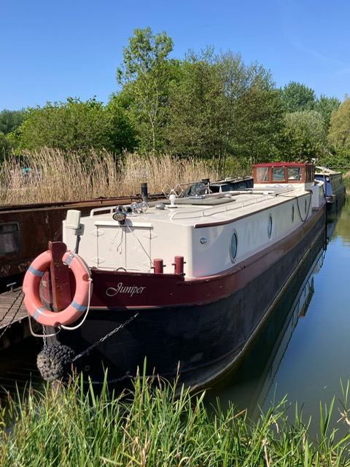

Juniper is a 57ft narrow beam Dutch barge that blends modern charm with smart design. Her bright, airy layout maximizes space, offering a versatile and inviting environment perfect for relaxed cruising or comfortable living.

Boat Specification
Year of Construction | 2018
Hull Plating Specification | Steel 10/6/4
Keel | Flat
No. Berths | 2+2

History of Vessel / Maintenance
Boat Safety Certificate Expiry | May 2027
Recent Survey | N/A
Latest Hull blacking | 2021
Anodes | 2021

Boat Description
Step aboard Juniper, a beautifully presented 57ft narrowbeam Dutch barge-style boat that effortlessly combines character with contemporary living. Her distinctive profile and thoughtfully designed layout offer the perfect balance of style and practicality.
Inside, you’re welcomed by a bright, open-plan living space featuring a well-equipped galley kitchen with modern appliances, generous storage, and stylish fittings. The saloon is light-filled and inviting, enhanced by an L-shaped sofa and dinette-style seating area toward the bow—perfect for relaxing or entertaining. A large window light in the ceiling floods the space with natural light, while classic portholes provide privacy and ambiance.
The galley’s sociable layout allows you to cook and chat effortlessly with guests, making it a functional yet welcoming heart of the boat. Toward the aft end of the cabin, a well-appointed bathroom includes a full-size shower, contemporary fittings, and an intuitive touchscreen shower control system for a touch of modern luxury.
Midships, the wheelhouse deck space houses the reliable 50hp Barrus engine and creates a versatile living area. With the canopy sides in place, it offers a sheltered haven to relax out of the elements. Open it up, and you’ve got the ideal cruising deck for enjoying the waterways.
To the stern, the spacious aft cabin features a comfortable double bed tucked away for peace and quiet. It also includes a second cassette toilet and handbasin—adding a practical touch and nighttime convenience without needing to cross the deck.
With clever use of space, stylish touches throughout, and a layout ideal for both adventure and everyday life, Juniper is perfectly suited for leisure cruising or as a comfortable floating home.

Engine Specification
Engine Make | Barrus Shire
Engine Hours | Not recorded
Bow Thruster | Yes
Diesel Tank Capacity | 250 litres - Approx
Additional Systems | Fuel guage

Water & Heating Systems
Source of Hot Water | Calorifier, immersion, Webasto
Central Heating | Webasto – radiators + 240v electric underfloor heating
Solid Fuel Stove | N/A – electric stove effect
Water Tank Capacity | 500 litres – water gauge
Water Tank Material | Stainless steel
Water Pump | Jabsco

Electrical System and Components
14-Volt System/Lighting | Standard + LED lights
14-Volt System/Power | Standard
240 Volt | Shorepower
Inverter | Victron 3kW invertor charger
Solar Panel | Yes + Mppt charge controller
Batteries | 6 x 2v domestic, 1 starter
Other systems | Galvanic Isolator, Victron Smart Battery Monitor with Bluetooth Smart Phone Connect

Bathroom Specification
Type of Toilet | Thetford Cassette – forward and aft cabin
Shower/Bath | Large shower room Mira touchscreen shower control
Handbasin | Glass with mixer tap
Additional Information | Whale 220 Gulper Shower pump

Kitchen Specification
Cooker | Belling built in double oven
Hob | Thetford 3 burner LPG hob
Fridge | 12v Fridge and 240v freezer
Gas | 2 x 13kg
Additional Systems

Additional Photos
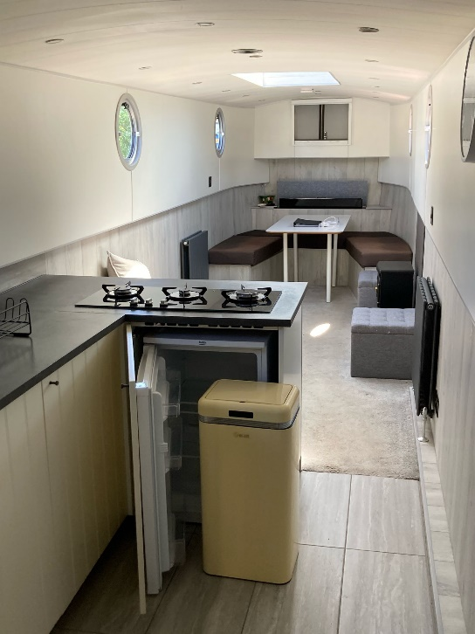 | 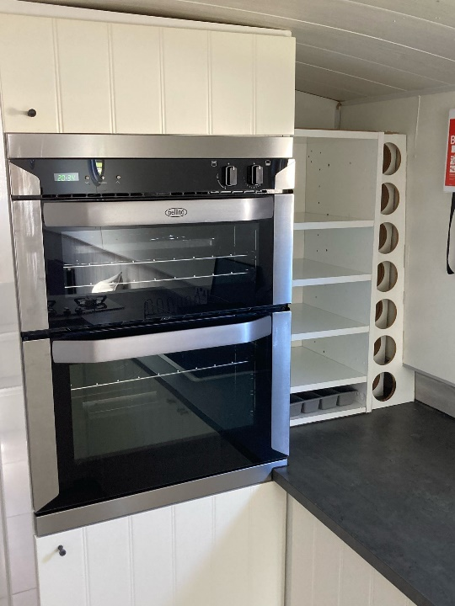
Galley facing fore | Galley facing aft
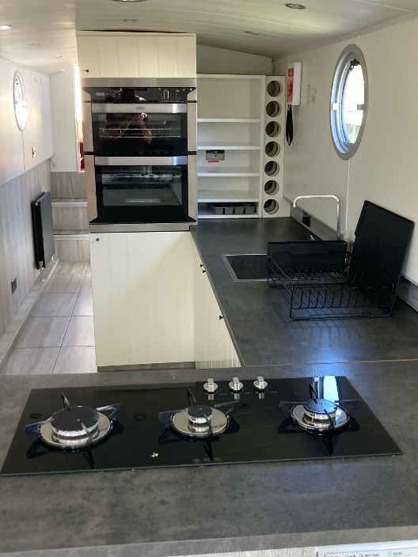 | 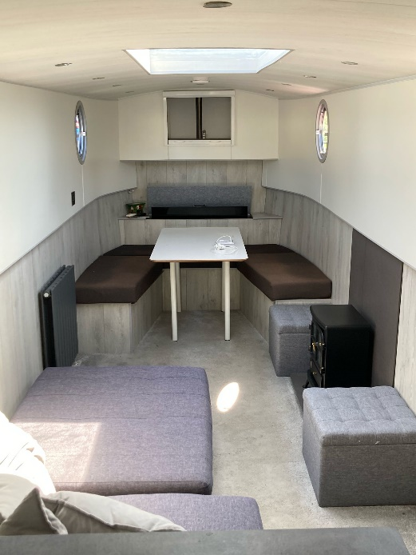
Galley facing aft | Saloon facing fore
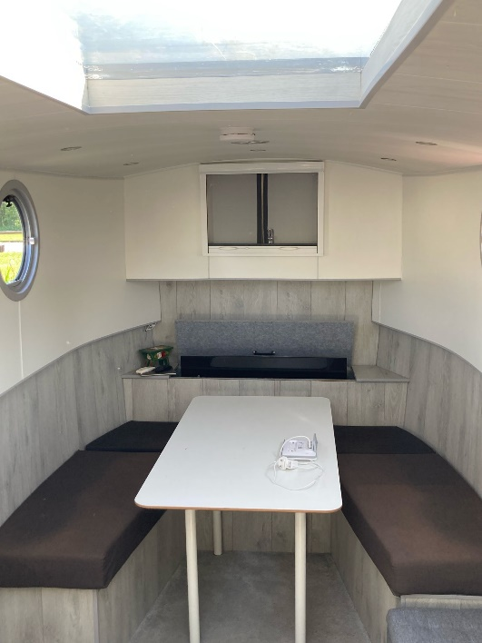 | 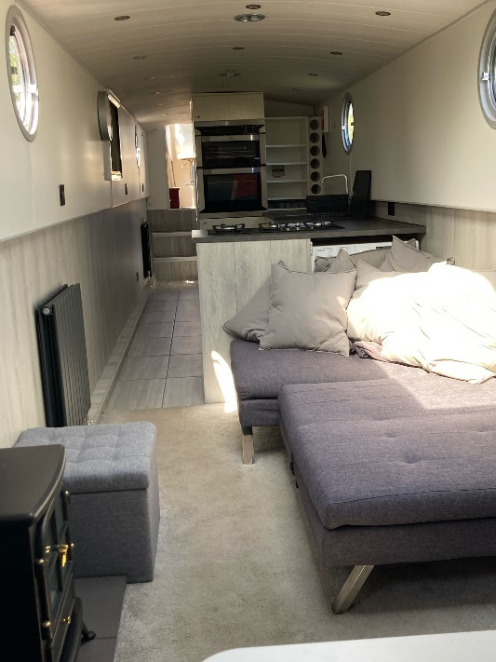
Saloon facing fore | Saloon facing aft
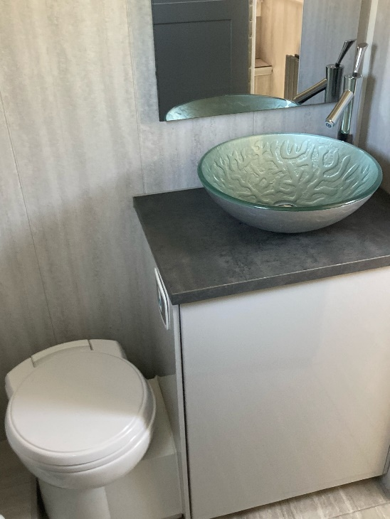 | 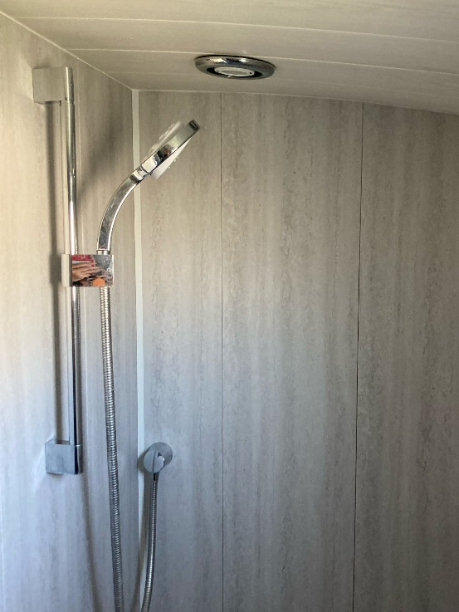
Shower room | Shower room
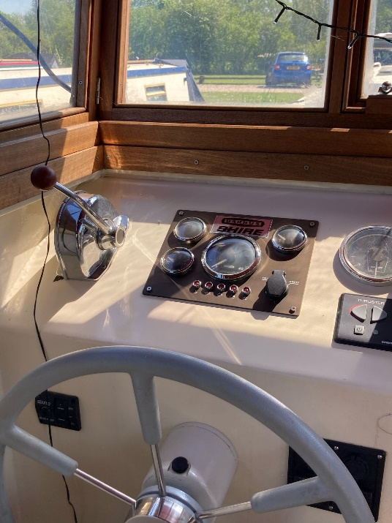 | 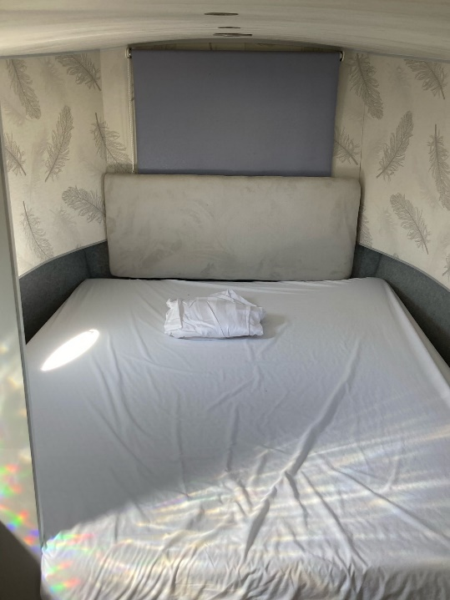
Wheel house | Bedroom facing aft
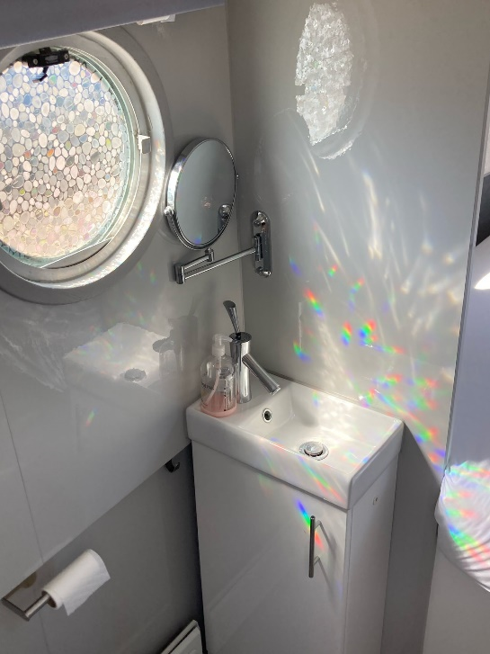 | 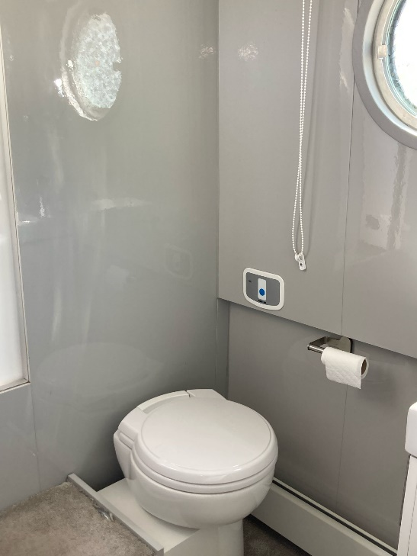
bedroom sink | Bedroom toilet
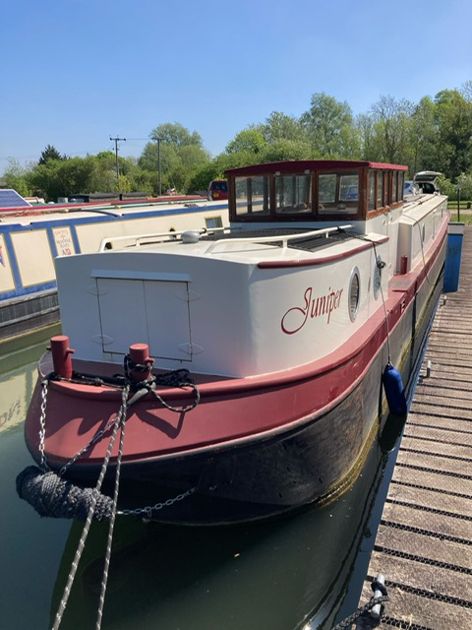 | 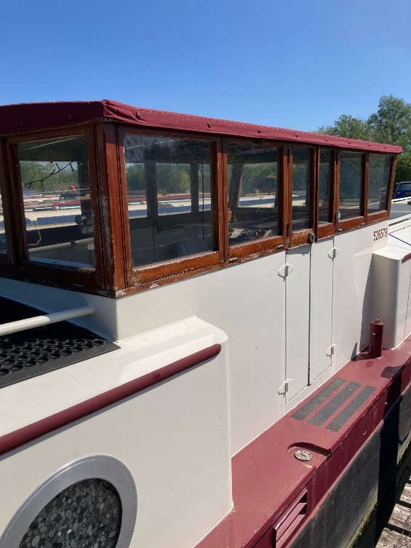

NOTE:
In this transaction we are acting as Brokers only. Whilst every care has been taken in their preparation, the correctness of these particulars is not guaranteed. The particulars are intended only as a guide and they do not constitute a term of any contract. A prospective buyer is strongly advised to check the particulars and where appropriate to have the vessel fully surveyed and inspected, water trialled and opened up".

